pageTitleImage7r



Exor Corporation Limited



Alert Manager

Admin v4.3



# 

The Global Leader in

Infrastructure Asset Management



This page intentionally blank.

Quality Assurance Statement

|  |  |
| --- | --- |
| **Document Details** | |
| **File:**  Alert Manager v4.3.pdf | **Prepared by:**  A Hammond/I Skinner |
| **Manual Name:**  Alert Manager v4.3 | **Reviewed by:**  **I Skinner** |
| **Version:**  3.0 | **Approved for issue by:**  T.C.Stewart |
| **Date of Issue:**  Nov 2010 | **Product Manager:**  T.C. Stewart |
| **File Name:**  Alert Manager v4.3.pdf | |

|  |  |  |  |  |
| --- | --- | --- | --- | --- |
| **Document Version Control** | | | | |
| **Revision** | **Date** | **By** | **Chapter / Page** | **Description** |
| 3.0 | Nov 2010 | IS | All | Released for v4.3 |

Contents

Quality Assurance Statement i

Alert Setup – HIG1520 5

General Information 5

Triggered Events 6

On Update Of 8

Attribute Condition 9

Mail Setup 11

Scheduled Events 14

Example of setting Alert for Triggered Event 16

Example of setting Alert for Scheduled Event 18

Example of setting Alert for a Process Alert 20

Attachments 22

Alert Logs – HIG1525 23

General Information 23

Sorting Results 24

Alert Logs 24

Chapter

1

Introduction

The purpose of Alert Manager is to manage the automatic generation of email notifications (Alerts). Alert Manager relies on the System Administrator configuring business rules that define the precise content of emails and the conditions under which an email is to be sent. These rules may be implemented using database triggers or saved queries, depending on the nature of the alert.

Alert Manager is based on the asset metamodel as defined in the ***Asset Metamodel – NM0410***. This means that any Oracle base table that is to be the subject of an alert must first be configured as a foreign table asset using form ***Asset Metamodel – NM0410***.

Attributes can be given user friendly names rather than using the underlying database column names which is particularly important when generating email text from flexible attributes or specifying conditions based on flexible attributes.

Alert Manager will currently alert for new or updated data by default in:

* Work Orders
* Work Order Lines
* BOQ items
* Defects
* Enquiries
* Automated processes

Note: System Administrators may configure additional tables that are to have alerts placed on the data therein. To carry out his task refer to the *Asset Manager Admin* guide.

Alerts may be sent to:

* Users linked to the module used (recorded by, primary contact, etc)
* Any exor or non exor users
* Any group of users

Alert manager allows emails to be sent in a batch. Instead of receiving individual emails a user can receive a single email with a table of details.

This chapter describes the forms used for configuring Alert setup and viewing Alert logs.

They are the following options:

* Alert Setup - HIG1520
* Alert Logs - HIG1525

The form descriptions provide you with detailed information including:

* an overall description of the form.
* a detailed explanation of each field, including available features (such as List of Values, default values and other characteristics).
* helpful information for using the form.

Alert Setup – HIG1520

Figure 1

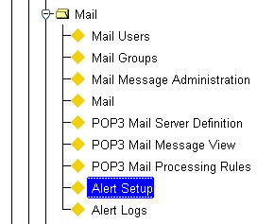Alert Setup

Menu Option

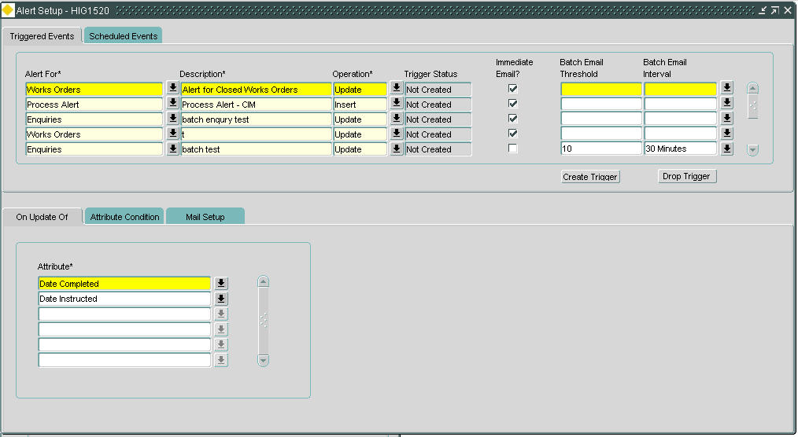Figure 2

Alert Setup

General Information

This form is used to define the business rules to automatically create and send emails based events that have occurred (e.g. a Category 1 defect being recorded) or the results of a saved query (e.g. Defects due for repair within the next 7 days)***.***

The precise content of the emails can be configured and the conditions under which an email is sent defined. These conditions are:

* Immediately
* After a given time
* After a given number of instances
* When a scheduled event occurs

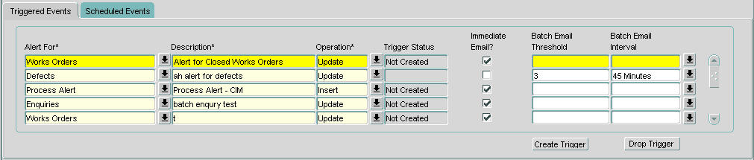Figure 3

Triggered Events

Triggered Events

Triggered events can be set up when the business rule behind the alert is based on the event.

When you enter this window, the cursor sits in the *Alert for* field waiting for you to enter your new data. Press [**Execute Query**] to obtain existing information.

Alert For (Required) List

Enter the Item on which alert triggers should be created.

Only foreign table assets will be available for selection. Currently the default list consists of the following:

* Work orders
* Work order lines
* BOQ items
* Defects
* Enquiries
* Automated processes

Note: System Administrators may configure additional tables that are to have alerts placed on the data therein. To carry out his task refer to the *Asset Manager Admin* guide.

Description (Required)

Enter a description of the alert. It is important that a sensible description is entered as there may be multiple alerts for each of the items listed above and the description is the only way to quickly identify the alert details.

Operation (Required) List

Enter the operation type. An operation type will depend on whether the alert has been defined to act on one of the following:

1. Creation of a new item – *Insert*.
2. The update of an existing item – *Update*. The ‘Update’ tab is only available with this operation set.
3. The deletion of an item – *Delete*.

Values available are Insert, Update or Delete.

The operation cannot be updated on a saved alert, if a change is required it should be deleted and re-entered.

Trigger Status (Display Only)

The status of the alert trigger will be displayed. This could be Enabled, Disabled or Not Created. Once the trigger has been created or edited it will need to be enabled, this is done by selecting the required alert and selecting the [Create Trigger] button.

When the alert criteria is edited, the system will automatically drop the trigger so consistency is maintained, a message will be displayed informing the user of this.

Immediate Email? (Optional)

When this box is checked emails will be sent immediately to the recipient(s) set up in the Mail Setup tab.

This may generate a large number of individual emails, if this is the case then the batch email options below should be considered.

Batch Email Threshold (Optional)

This field is available only if the ‘Immediate Email’ field is left unchecked.

When emails need to be sent in a batch then the count of the number of emails to trigger the batch can be entered.

If the ‘Batch Email Interval’ is reached before the threshold then the email will be sent.

Batch Email Interval (Optional) List

When emails need to be sent in a batch then the time interval can be entered.

If the ‘Batch Email Threshold’ is reached before the interval then the email will be sent. The interval is required because if a ‘Batch Email Threshold’ is never met then the required users may never be alerted as required.

Note: when both the ‘Batch Email Threshold’ and ‘Batch Email Interval’ fields are populated the batch will be triggered for whichever is the earliest.

**[Create Trigger]**

Use this button to create a database trigger against the Oracle table named by the foreign table set against the asset metamodel in form ***Asset Metamodel – NM0410***. Once created the ‘Trigger Status’ field will be highlighted in green with the ‘Enabled’ text being displayed.

If an existing alert is modified for any reason the user will have to re-create the trigger with this button before the alert will function.

**[Drop Trigger]**

Use this button to drop the Oracle trigger created for generating the alert. The trigger status will change to ‘Not Created’ when this button is selected.

This will disable the trigger until it is required to be re-created using the [Create Trigger] button.

Editing the criteria will also drop the trigger, the user will be notified the trigger will need re-creating.

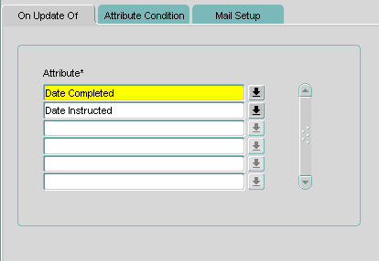

Figure 4

On Update Of

On Update Of

Alerts can be triggered on the update of any attribute within the selected items metamodel. The list of values will contain all attributes held against the selected item type in the ‘Alert For’ field.

This tab will be enabled only if the ‘Operation’ is defined as ‘Update’.

Attribute (Optional) List

Enter the attribute that, if updated, is to be used for the alert trigger.

If multiple attributes are entered here the alert will be sent on update of either of the selected attributes.

Note: this field can be left blank if the alert is to be generated for any modified attribute on the item selected.

Figure 5

Attribute Condition

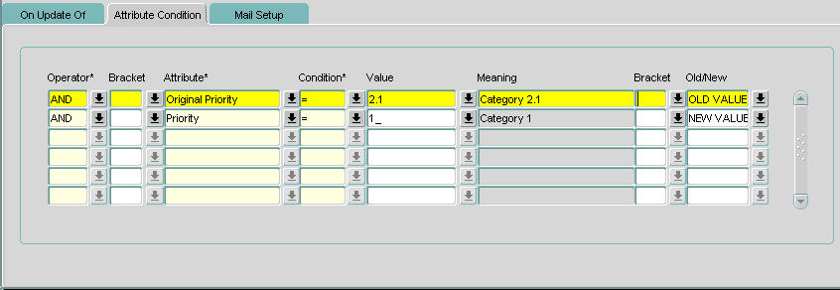

Attribute Condition

Alerts can be triggered if the attributes meet the conditions defined in this tab.

Operator (Required) List

Enter the operator for the condition. Valid values are AND and OR, default is AND.

Bracket (Optional) List

Enter the opening bracket of the condition if required.

Attribute (Required) List

Enter the attribute to be used for the condition.

The list of values will contain all attributes held against the selected Item type in the ‘Alert For’ field.

Condition (Required) List

Enter the condition to be used for the attribute. These are a subset of standard Oracle conditions.

If a condition of ‘BETWEEN’ is required ‘>=’ ‘AND’ ‘<=’ should be used with the appropriate brackets for a sensible condition. An example of this is shown below:

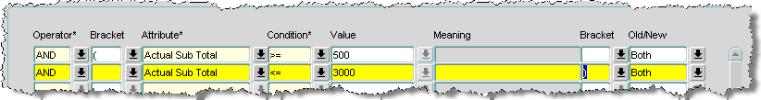

If a condition of ‘IN’ is required several ‘=’ and ‘OR’ should be used with the appropriate brackets for a sensible condition. An example of this is shown below:

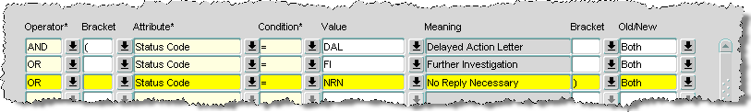

Value (Required) List

Enter the required ‘query’ value of the currently selected attribute. If the attribute values are held in a domain, the list of values may be called.

If the LIKE condition is used wildcards ‘%’ or ‘_’ may be used in the value field.

Meaning (Display Only)

If the attribute values have an associated list of values the description of the selected value will be displayed.

Bracket (Optional) List

Enter the closing bracket of the condition if required.

Old/New (Required) List

This field is used to check the attribute for values that are either old, new or both.

This field is applicable only if the ‘Operation’ is defined as ‘Update’.

Note

Both Documents and Enquiries are stored in the dame table, to ensure that new documents added to the system are not included in the emails that may be sent be sure to exclude documents by adding some enquiry related criteria to the attribute condition.

For example, adding ‘Status code’ IS NOT NULL should exclude documents.

Figure 6

Mail Setup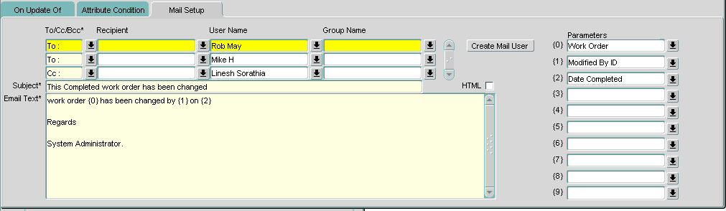

Mail Setup

Alerts may be sent or copied to:

* Users that are linked to the module used
* Any exor or non exor users
* Any group of users

Up to 10 parameters can be defined for inclusion in the ‘Email Text’.

To/Cc/Bcc (Required) List

Enter the recipient type.

Recipient (Optional) List

Enter the recipient of the email. This will be a user linked to the module, for example with enquiries; Recorded By, Primary Contact, Resp of User and All Contacts would be options.

The list of values will contain attributes of the ‘Alert For’ type that store user_id or attributes that can derive the email id.

User Name (Optional) List

Enter the mail user who is to receive the email.

These will have been set up previously in form ***Mail Users – HIG1900***.

These may also be set up whilst defining the e-mail criteria by selecting the [Create Mail User] button.

Group Name (Optional) List

Enter the group who is to receive the email.

These will have been set up previously in form ***Mail Groups – HIG1901***.

From (Optional)

Enter some text that defines who the email has been sent from, for example, ‘System Administrator’.

HTML (Checkbox)

Check this box if the email is to be sent in HTML format. This allows the formatting and semantic mark-up capabilities in the email that are not available with plain text emails.

Subject (Required)

Enter the subject of the email.

Parameters can be included in this field, see Parameters below.

Email Text (Required)

Enter the text of the email.

Parameters can be included in this field, see Parameters below.

Parameters (Optional) List

Enter the parameters to be included in the email.

Up to 10 parameters can be defined for each alert. All the attributes against the item selected in the ‘Alert For’ field will appear in the list of values.

Parameters can be embedded in the ‘Subject’ and ‘Email Text’ fields using the label provided for each parameter. For example {0}. The value within the brackets will be replaced in the email with the value of the parameter.

As shown in the example below, parameter {0}, {1} and {2} will be replaced with Enquiry Id, Description and Location.

Figure 7

Parameters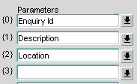

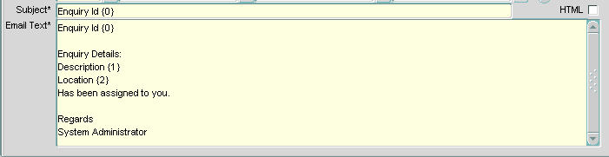

Figure 8

Email text

If the ‘Triggered Events’ are to be batched the batch email will have a table embedded into the email body with the list of parameters selected. This table can be embedded into the mail with a TAG {table} in the ‘Email Text’ field. An example of this is shown below.

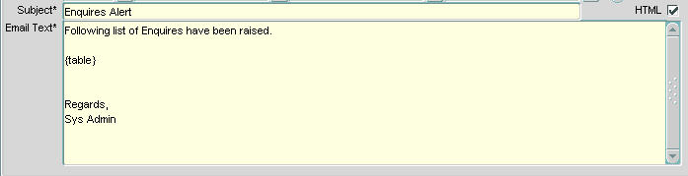

Figure 9

Batch Email

Text

Batch email will not be able to replace an individual parameter which can be specified for immediate email i.e. {0}, {1}

If an email containing a table of data is to be sent the HTML checkbox should be checked.

**[Create Mail User]**

This button will call form ***Mail Users - HIG1900*** where a new mail user can be set up.

Figure 10

Mail Users

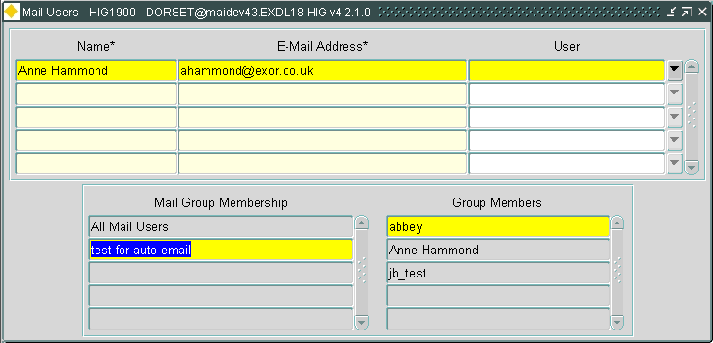

Name (Required)

Enter the name of the mail user. This name can be viewed and updated in the Display Name field in the E-mail tab of the ***Users – HIG1832*** form.

E-mail Address (Required)

Enter the above users email address. The system will not check this is a valid email address so care should be taken when entering the information.

User (Optional) List

If the email address needs to be linked to an existing user of the system as entered through the ***Users – HIG1832*** form that user may be selected from a picklist. If the selected user already has an email address an error will be displayed. To update an existing users e-mail address use the ***Users – HIG1832*** form.

Mail Group Membership (Display Only, Query)

All of the mail groups that the selected user belongs to will be displayed. These may also be queried to search for group membership.

Group Members (Display Only, Query)

When a mail group is selected in the Mail Group Membership field, all members of the selected group will be displayed. These may also be queried to find other users within this group.

Figure 11

Scheduled Events

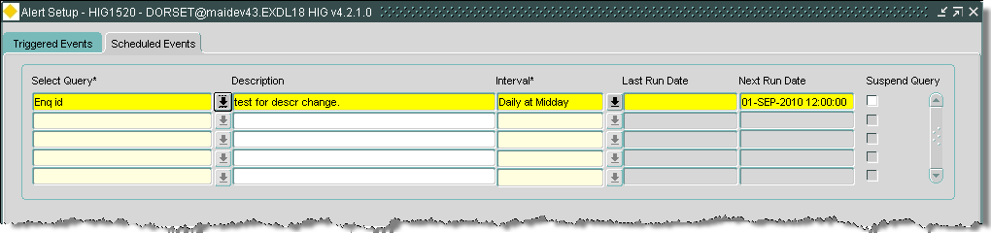

Scheduled Events

When you enter this tab, the cursor sits in the Select Query field waiting for you to enter your new data. Press [**Execute Query**] to retrieve existing information.

Alerts can be sent out based on the results of a saved query. Queries can be defined and saved in the Navigator/Query Builder module and used here or defined here for use within Alerts.

Select Query (Required) List

Select the query to be used for the scheduled events.

Query Builder will be called from where an existing query can be selected.

A new query can be defined here as well if required, See the Navigator and Query builder documentation.

Figure 12

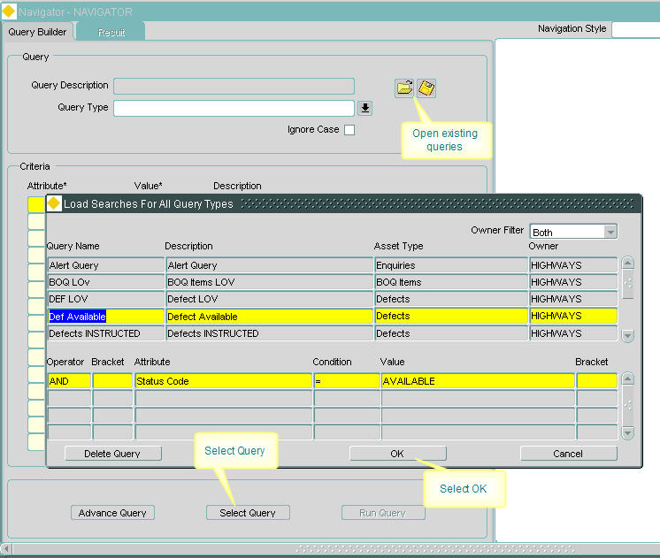

To select an existing query:

1. Select the picklist, this will display the Query Builder form.
2. Select the Open Folder icon  to display existing queries.
3. Highlight the required query, select the [OK] button, this will display the query and its associated criteria
4. Select the [Select Query] button to return the query to the form

Description (Display Only)

A description of the selected query will be displayed. This can be modified for the alert as required.

Interval (Required) List

Enter the interval between the running of the query, for example every 10 minutes. This can also be set to run the query at a specific time of the day, for example at the end of the working day 5:50pm.

The intervals are defined by the system administrator using ***Scheduling Frequencies – HIG2530.***

Last Run Date (Display Only)

The last date and time the query was run will be displayed.

Next Run Date (Display Only)

The next date and time the query will run will be displayed.

Suspend Query (Display Only)

When this box is checked the query will be suspended and the alerts generated will be stopped.

Example of setting Alert for Triggered Event

This example is using an alert for Enquiry Manager.

Once the responsibility of enquiry has been assigned to an officer the system will notify the officer by email. The email shall contain:

* Enquiry Id
* Enquiry description
* Enquiry location

Set up triggered event with fields:

1. Alert For – ‘Enquiries’
2. Operation – ‘Update’
3. Immediate Email? – ‘ticked’

On ‘Update Of’ tab

1. Attribute - Resp of User

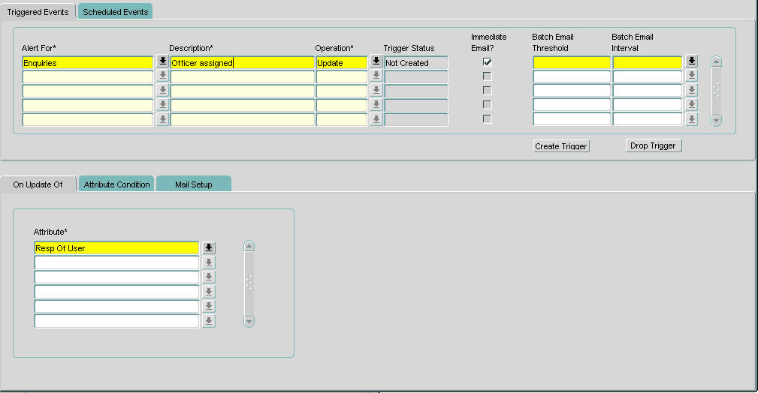

Figure 13

On ‘Mail Setup’ tab set the fields:

1. To/Cc/Bcc – ‘To:’
2. Recipient – ‘Resp of User’
3. Subject – ‘Enquiry Id {0}’
4. Email Text to read:

Enquiry Id {0}

Enquiry Details

Description {1}

Location {2}

Has been assigned to you

Regards

System Administrator

1. Parameters -

{0} - Enquiry Id

{1} - Description

{2} - Location

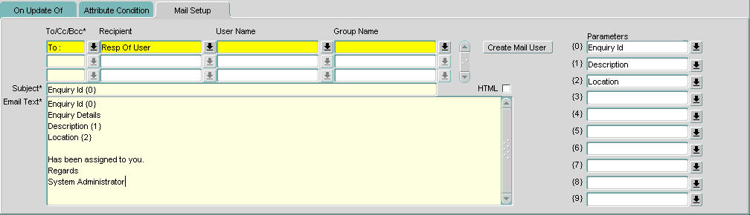

Figure 14

1. Save the record.
2. Select the [**Create Trigger**] button to start creating the Alerts.

This will now start sending email alerts to the Responsible Officer when the ‘Responsibility Of’ field is changed.

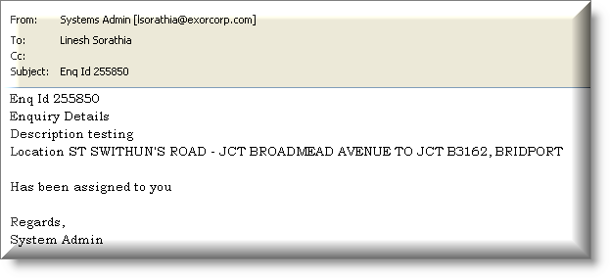

Figure 15

Email alert

Example of setting Alert for Scheduled Event

This example is using an alert for a saved query.

If a work order a user has requested to be instructed has not been instructed within 10 days the system will notify the officer who raised the work order by email. The email shall contain:

* Work Order number
* Date work order raised.

1. Select the ‘Scheduled Events’ tab.
2. In the ‘Select Query’ field press the ‘drop down list’ icon to open ‘Query Builder’.

This will call the Navigator/Query Builder module.

1. Open the list of saved queries using the ‘Open File’ icon.

This will open the ‘Load Searches For All Query Types’ window.

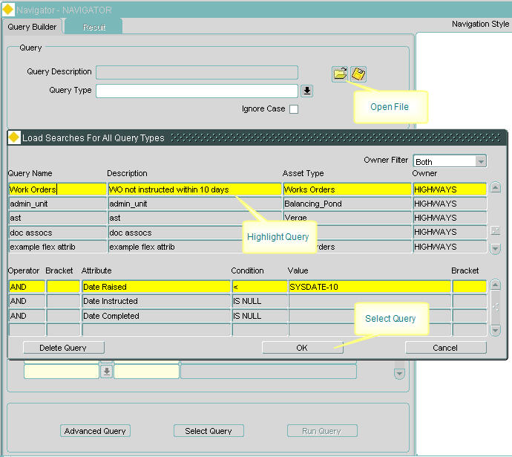

Figure 16

1. Highlight the saved query and press [**OK**] to put the query into Query Builder.

Figure 17

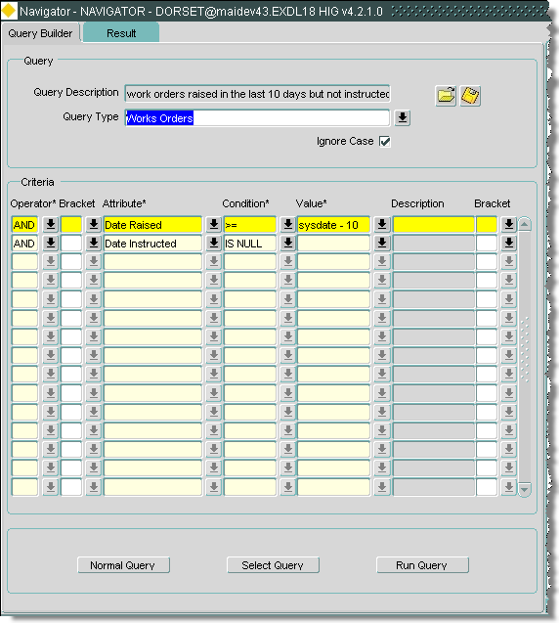

1. Press the [Select Query] button to put the query into the ‘Scheduled Events’ module.
2. In the ‘Interval’ field press the ‘drop down list’ icon and select the interval between the running of the query.

On ‘Mail Setup’ tab set the fields:

1. To/Cc/Bcc – ‘To:’
2. User Name – ‘System Administrator’
3. Subject – ‘Work Order {0} not instructed’
4. Email Text to read

Work Order {0} raised on {1} has not been instructed yet.

Regards

System Administrator

1. Parameters -

{0} - Work Order

{1} - Date Raised

1. Save the record.

Based on the interval the query will be run and the recipient of the resultant data will be sent out as emails.

Example of setting Alert for a Process Alert

This example is using an alert for a Process Alert.

Alerts can be set up for any batch that runs from Process framework. Asset metamodel ‘PRO$’ will be shipped as standard to set up the alerts (refer to the Asset Administration Guide for further information). Setups can be done to trigger alerts on Success, Failure or Interim processing of the batch.

Note:

Interim is used for the Maintenance Inspection Loader, the loader may have succeeded in automatically loading the inspection whilst an interim process (automatically creating a work order) may have failed.

The email shall contain:

* Contract Id
* Process Id
* Outcome

Set up triggered event with fields:

1. Alert For - Process Alert
2. Operation - Insert
3. Immediate Email? - ticked

On ‘Attribute Conditions’ tab

First condition

1. Operator - ‘AND’
2. Attribute – ‘Process Type’
3. Condition - ‘=’
4. Value – ‘-1002’ (CIM Work Order Extract)

Second condition

1. Operator – ‘AND’
2. Attribute – ‘Outcome’
3. Condition – ‘=’
4. Value – ‘N’ (Fail)

Figure 18

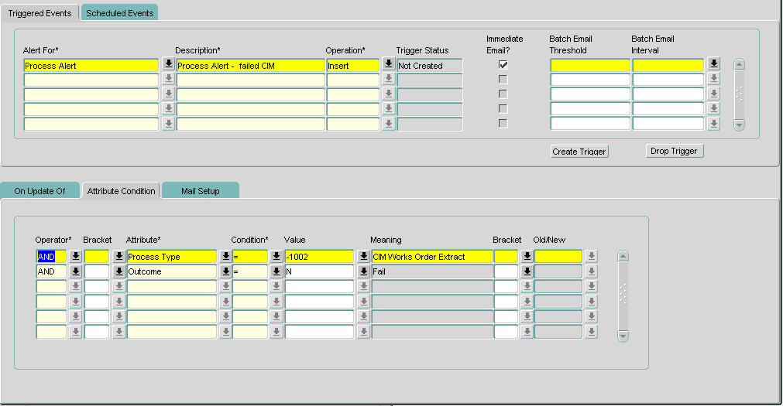

On ‘Mail Setup’ tab set the fields:

1. To/Cc/Bcc - ‘To:’
2. Recipient - ‘CIM Contact’
3. Subject - ‘Contract {0}’
4. Email Text to read

Contract {0}

Process {1} has an outcome of {2}

Regards

System Administrator

1. Parameters -

{0} - Contract Id

{1} - Process Id

{2} - Outcome

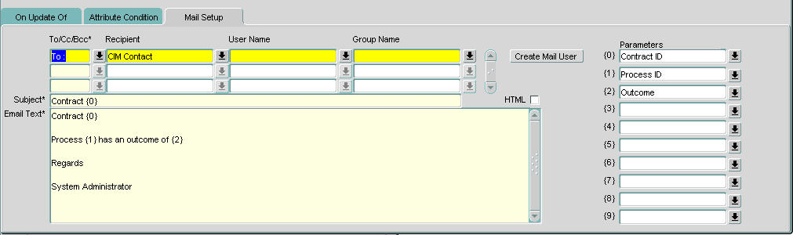Figure 19

1. Save the record.
2. Select the [**Create Trigger**] button to start creating the Alerts.

This will now start sending email alerts to the CIM Contact when a CIM work order extract fails.

Attachments

Attachments will be available for any alert triggered through the Process Alert Log. Any alerts triggered from the Process Alert Setup will always have the detailed Process Execution Log as an attachment. The attachment file will be in the format:

File Name Log for <<Process Name>><<System Date>>.txt

e.g. Log for CIM Works Order Extract 10-MAY-2010.txt

Note: email attachments can only be included on alerts against the Process Alert metamodel. There is no provision for email attachments on other metamodels.

Note: If a Process Alert is set up with a batch email there will not be any attachments as it is not possible to have multiple attachments on the email.

Alert Logs – HIG1525

Figure 20

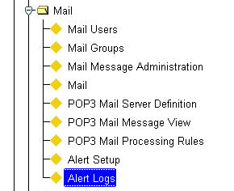Alert Logs

Menu Option

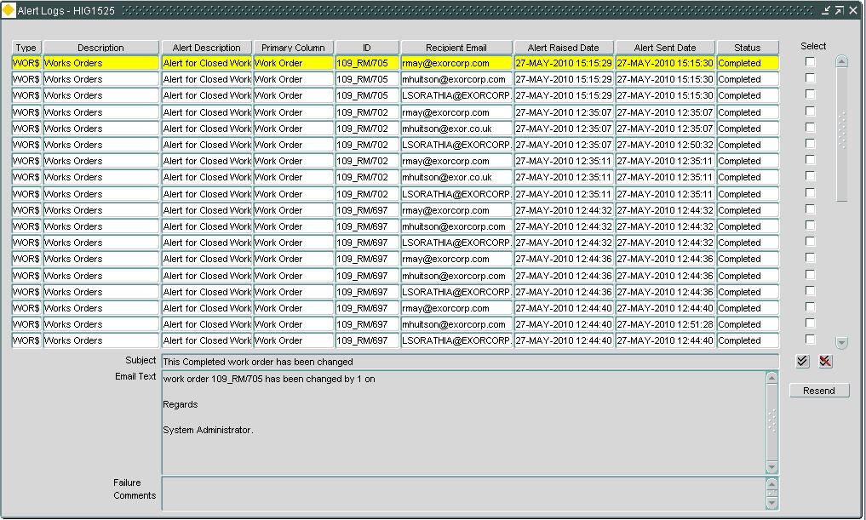

Figure 21

Alert Logs

General Information

This module is used to view alert logs and to resend any alerts.

It shows the status of the alert. If any alert has failed, details of the failure are displayed in the ‘Fail Comments’ field.

All fields in this screen are queryable. Users can, for example, query back all failed alerts and resend alerts as required.

Sorting Results

Results within the Alert Log module may be sorted by any of the displayed fields by pressing the field name (column heading) which are also ‘Sort’ buttons. The first time a heading is pressed the records are sorted in ascending order. If pressed again the records within the column will be sorted in descending order. A ‘carat’ (^) symbol or lower case ‘v’ is displayed adjacent to the column name to indicate that the data has been sorted in ascending or descending order respectively as shown below.

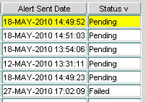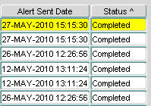 Figure 22

Sort

Alert Logs

Failed alerts can be selected and re-sent.

Type (Display Only)

The Item on which alert triggers are configured will be displayed.

Description (Display Only)

The description of the item will be displayed.

Alert Description (Display Only)

The description of the alert as defined in Alert Setup – HIG1520 will be displayed.

Primary Column (Display Only)

The primary column of the item will be displayed.

The primary column is the screen text of the primary key column as defined in the ***Asset Metamodel – NM0410***.

ID (Display Only)

The value of the primary column will be displayed.

Recipient Email (Display Only)

The email address of the recipient of the alert will be displayed.

Alert Raised Date (Display Only)

The date the alert was raised will be displayed.

Alert Sent Date (Display Only)

The date the email was sent containing the alert will be displayed.

Status (Display Only)

The status of the alert will be displayed. This could be Completed/Failed or Pending.

Select (Checkbox)

This box should be checked if the alert is to be resent.

Subject (Display Only)

The subject of the alert email will be displayed.

If parameters have been entered into the subject the actual value will be shown.

For example: If the subject was entered as ‘Enquiry Id {0}’ this would be shown as ‘Enquiry Id 313291’.

Email Text (Display Only)

The text of the email will be displayed.

If parameters have been entered into the email text the actual value will be shown.

For example: If the text was entered as ‘Work Order {0}’ raised on {1} has not been instructed would be shown as ‘Work Order 109_RM/697 raised on 10-MAY-2101 has not been instructed.

Failure Comments (Display Only)

If the alert failed details of the failure will be displayed.

To resend all failed alerts:

1. Select the [**Enter Query**] button.
2. In the ‘Status’ field enter ‘Failed’.
3. Select the [**Execute Query**] button to retrieve all failed alerts.
4. Press the [**Select All**] button to select all failed alerts.
5. Press the [**Resend**] button to resend all failed alerts.

The [**Deselect All**] button is used to deselect all selected alerts.